Introduction
At Parc Eglos School the Local Governing Committee, Headteacher, Leadership Team and all staff are committed to creating an environment where exemplary behaviour is at the heart of productive learning. Everyone is expected to maintain the highest standards of personal conduct, to accept responsibility for their behaviour and encourage others to do the same. Our Positive Relationship policy guides staff to teach self-discipline not blind compliance. It echoes our core values:
Love is the key to being Safe
Teamwork is the key to Belonging
Courage is the key to Success

Aims and Objectives
- To create a culture of exceptionally good behaviour: for learning; for community; for life.
- To ensure that all pupils are treated fairly, shown respect and that positive relationships are promoted.
- Have respect for the rights and beliefs of others.
- To ensure that attention and a sense of importance is given to pupils for positive behaviour choices.
- To help pupils self-regulate and be responsible for their own behaviour.
- To build a community which values kindness, care, good humour, self-regulation, self-efficacy and empathy for others.
- To promote community cohesion through positive relationships.
- To ensure that excellent behaviour is celebrated and normalised.
- To increase inclusion.
Expectations (Ready, Respectful and Safe)
Ready, Respectful and Safe are the three rules which underpin our Positive Relationship policy.
‘Ready’ - Ready to learn, ready to listen, ready to participate etc.
‘Respectful’ - Respect for themselves, their peers, adults, and our environment.
‘Safe’ - Safe in their learning environment, safe with the people around them, and safe in the activities in which they are taking part.

The statements within yellow are standard across all schools in Crofty Education Trust and are included in each school’s behaviour policy.

Definitions

When read or used in relation to this document and/or the DfE’s ‘Suspension and permanent exclusion from maintained schools, academies and pupil referral units in England, including pupil movement: Guidance for maintained schools, academies, and pupil referral units in England, August 2024’ the following definitions will be adopted by Crofty Education Trust and all Crofty schools.

Headteacher | Shall relate to the Headteacher, Executive Headteacher, and/or Head of School
Governors/Trust Board | Shall relate to the Board of Trustees, and the Crofty Local Governance Committees (LGC)
Parent | The definition of a ‘parent’ can be found in the Education Act 1996, and this applies to all the legislation to which this guidance relates. In addition to the child's birth parents, references to parents in this guidance include any person who has parental responsibility (which includes the local authority where it has a care order in respect of the child) and any person (for example, a foster carer) who has care of the child. To reflect this, this guidance uses ‘parent’ to refer to both parents and carers.

Rights
Every person in the school has rights. Each teacher has the right to teach without disruption and children have the right to learn without interference.
Consistent Adult Behaviour
At Parc Eglos School, we understand that positive, rewarding relationships and excellent standards of behaviour are built on the solid foundations of love and trust. These behaviours are established when adults are uncompromisingly consistent in their modelling and delivery of this relationship policy.
At Parc Eglos School, adults:
- Meet and greet positively and in a personal way at the start of the day and after breaks and lunchtimes.
- Refer to the Ready, Respectful, Safe (RRS) rules when talking about children’s behaviour.
- Use appropriate language and tone.
- We always refer to the behaviour and not the child, this allows the child to understand that they have choices about their behaviour – they are not the behaviour.
- We use agreed, non-confrontational language when speaking to the children about behaviour choices. (this includes body language and neutral poses)
- Plan lessons that engage, challenge and meet the needs of all children.
- Follow up every time, retain ownership and engage in reflective dialogue with children.
- Never ignore or walk past children who are making poor behaviour choices.
Positive Recognition
At Parc Eglos School, we understand that the vast majority of our children will respond well when their efforts and achievements are recognised and celebrated.
We have a number of celebration strategies:
Reward system | Who for? | Why?
The teamwork award - Stars in a jar | Whole Class | Whole class rewards for classes who work together to follow the RRS rules
The success award - Postcards home | Nursery – Year 6  Individual | For pupils who have shown exceptional ‘in that moment’ achievement – academic or RRS
The Golden Key Award - Celebration Assembly | Y1 – Y6  Individual | Pupils of the week celebrations to recognise pupils who have achieved well against our school values that week.

Class Support
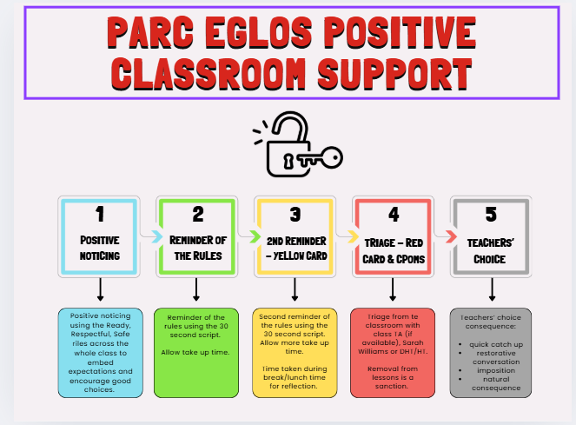

Students who commit a serious breach will be triaged immediately to the HT or DHT without support steps. This might include bullying (see separate whole school Anti-Bullying Policy),racist language, violence, homophobic behaviour.

Any student Triage will be recorded on CPOMs with the phase leader alerted to this entry. The class teacher leads the behaviour in the classroom using the Classroom Support Plan.

For the vast majority of pupils, a gentle reminder or nudge in the right direction is all that is needed. This may be a quiet word or a visual cue in order to correct the behaviour.

Although there are occasions when it is necessary, every minute a pupil is out of your lesson is one where they are not learning. Steps should always be taken with care and consideration, individual needs must be taken into account where necessary. Praise the behaviour you want to see and do not excessive attention to unwanted behaviour. All pupils must be given ‘take up time’ in between steps. It is not possible to leap or accelerate steps for repeated low-level disruption.
A reminder and warning of the expectations for pupils referring to the rules of ‘Ready, Respectful, Safe’ should be delivered privately to the pupil. The teacher makes them aware of their behaviour. The pupil has a choice to do the right thing. Pupils should be given time to respond to this request ‘take up time’.
A clear, verbal, final last chance warning should be delivered privately to the pupil making them aware of their behaviour and clearly outlining the consequences if they continue. Pupils will be reminded of their previous good conduct to prove that they can make good choices. It is important to give the pupil some time here to have the opportunity to reflect on what you have said and respond appropriately.
Scripted approaches at this stage are encouraged:
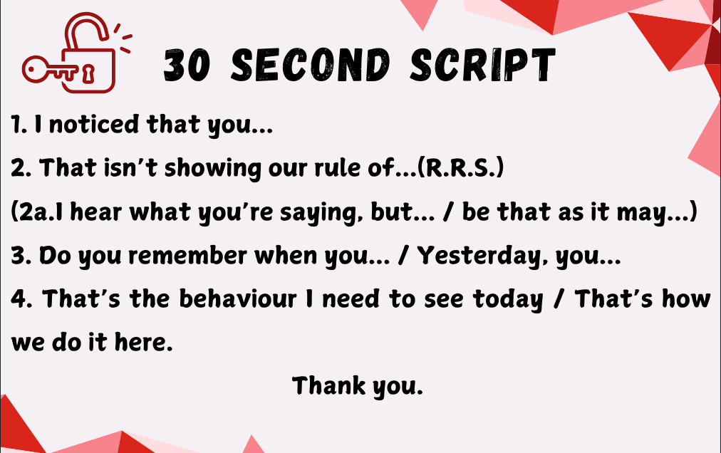
Walk away as soon as you have finished and praise pupils who are getting it right.
Following an incident where a pupil has been removed, it is important that the classroom teacher follows this up. ‘Picking up your own tab’ is a key principle here. The classroom teacher has the following options:
Catch up
Behaviour that results in a student being triaged may need no more consequences. However, it is very important, to catch up with the student before the next lesson, acknowledge that the previous lesson wasn’t good for anyone and that next lesson is a fresh slate. (This could take place with the pupil at the end of the day, in the playground, or phone call home.
Restorative Conversation
Walk and talk, stack books and talk, clean tables and talk. The Restorative Conversation is so much easier and more productive if it isn’t two people sat at a table making awkward eye contact. Much better to talk while doing something else.
The restorative 5:
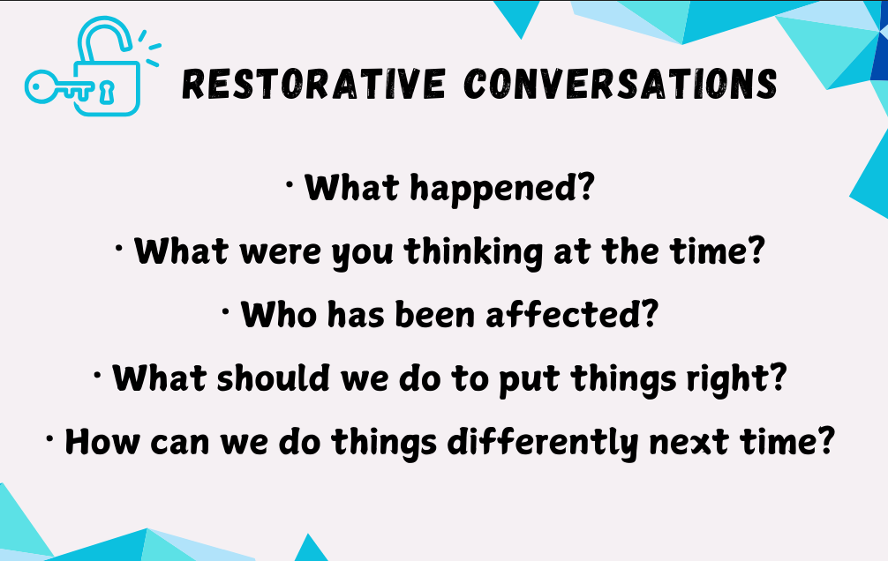These are questions for both the adult and the child. The purpose of the restorative
conversation is not to build to a climax of apology. Rather to get students to look in the
mirror and see their behaviour from a different perspective. It is a coaching conversation using a recent incident in sharp focus. There is real learning here, most of the time for the students, sometimes for everyone.

Imposition
Work that was not done in the lesson taken home, signed by a Parent/Guardian and returned before the start of the next lesson. Impositions are ideal for students who have not completed work due to their poor behaviour.

Natural consequence
Cleaning up the mess, repairing the display, reorganising the classroom, making up with peers are examples of natural consequences. If you can find a consequence that repairs the damage rather than just punishing the behaviour it all makes more sense.

What happens in Triage?
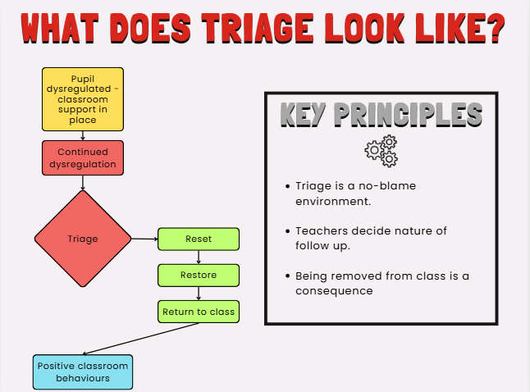

If a child needs to leave a space to aid self-regulation, a teaching assistant should, in the first instance, take this child to the nurture space or library. If a TA is not available, the DHT or HT will take this role.

1. Self regulating space
2. Opportunity to talk, access support and reset
3. Quiet place to study

Repair - Self regulating space
This is a quiet space using sensory aids/blackout tent/headphones/
happiness boxes (for regular attendees) until the student is ready to talk and access support to help regulate their emotions.

Restore - Space to talk, access support and reset
For most students the aim is for the repair/restore to take place straight away, if necessary, with the student staying in the nurture room for only one lesson and returning to their next lesson ready for learning. In some instances, there may be a need to unpick an underlying issue and this may take longer, to allow the student the time to regulate their emotions.

Return to learn - Quiet space to study
This would be the area where students would complete the work that they are missing due to being removed from class. There would always be an expectation that the work is completed. When ready and able, they will be returned to class. If notable amounts of work are missed, these should be sent home for completion, alongside a conversation with parents regarding why this work is being sent home, and the expectation and timescale for it to be returned to school.

Where patterns of behaviour are noted the following actions can be taken:
- Phase leaders to contact parents to discuss behaviour presentations.
- Internal exclusions can be used to support reflection
- Positive Transfer Inclusion – where a pupil attends an alternative CROFTY school for a short period of time 1-3 days to support reflection.
- Suspension
- Permanent exclusion.

Use of Suspension and Exclusion
Suspensions and Exclusions
Crofty Education Trust and all Crofty schools adopt, in its entirety, the DfE’s ‘Suspension and permanent exclusion from maintained schools, academies and pupil referral units in England, including pupil movement, Guidance for maintained schools, academies, and pupil referral units in England, August 2024’, which is available here.
In extreme cases, Parc Eglos Primary School may use suspensions or permanent exclusion.

Only the headteacher of the school can suspend or permanently exclude a pupil on disciplinary grounds.

The reasons below are examples of the types of circumstances that may warrant a suspension or permanent exclusion :
- Physical assault against a pupil.
- Physical assault against an adult.
- Verbal abuse or threatening behaviour against a pupil.
- Verbal abuse or threatening behaviour against an adult.
- Use, or threat of use, of an offensive weapon or prohibited item that has been prohibited by a school’s behaviour policy.
- Bullying.
- Racist abuse.
- Abuse against sexual orientation or gender reassignment.
- Abuse relating to disability.
- Deliberate damage to school property and/or premises.

Suspensions: A suspension, where a pupil is temporarily removed from the school, is an essential behaviour management tool. A pupil may be suspended for one or more fixed periods (up to a maximum of 45 school days in a single academic year). A suspension does not have to be for a continuous period. A suspension may be used to provide a clear signal of what is unacceptable behaviour as part of the school’s behaviour policy and show a pupil that their current behaviour is putting them at risk of permanent exclusion. Following a suspension, on the morning of their return to school, the child and parents will be invited to a reintegration meeting.

Permanent Exclusion: A permanent exclusion is when a pupil is no longer allowed to attend a school (unless the pupil is reinstated). The decision to exclude a pupil permanently should only be taken in response to a serious breach or persistent breaches of the school's behaviour policy and where allowing the pupil to remain in school would seriously harm the education or welfare of the pupil or others, such as staff or pupils in the school.

Prior to Exclusion: Before deciding whether to suspend or permanently exclude a pupil, the headteacher will:
- consider all the relevant facts and evidence on the balance of probabilities, including whether the incident(s) leading to the exclusion were provoked;
- allow the pupil to give their version of events;
- consider whether the pupil has any relevant special educational needs;
- consider whether the pupil is especially vulnerable (e.g. the pupil has a social worker, or is a looked-after child);
- consider whether all alternative solutions have been explored.

Children with additional needs: For children with additional needs, such as those with a Social Worker or SEND provision, due consideration will be given to their circumstances and needs, together with any adjustments or adaptations that have been made by the school.
Notifying Parents and other Parties of a Suspension or Exclusion: Without delay, the headteacher will notify parents, the Director of Education, and the Local Authority of a suspension or exclusion. When necessary, Social Workers, the Virtual School head, and the Trust Board will also be informed.

Exclusion Panels
A Committee of the Trust Board must meet and review the following exclusions:
- Permanent exclusion.
- Where a pupil will miss a public exam or national curriculum test because of the suspension.
- Suspension that will take a pupils total days of suspension above 15 days in one term.
The Headteacher, Parents, Local Authority and, when required, Social Worker and Virtual School Headteacher, will be invited to attend this review meeting within 15 school days, or before the date of the examination where possible. The outcome of the review meeting will be provided in writing, without delay.

Parents may make representations to the Trust Board Committee and request a review meeting for any suspension. If the suspension is fewer than 5 days in one term, the committee cannot reinstate the pupil. If the suspension is between 5.5-15 days in one term, the committee must consider the reinstatement of the pupil within 50 school days. The outcome of the review meeting will be provided in writing, without delay.

Independent Review Panels
In the case of a permanent exclusion, where the Trust Board Committee decided not to reinstate the pupil, parents have the right to request an independent review panel (IRP). Details of how to request an IRP will be included in the review meeting outcome letter. Applications for an IRP must be made within 15 school days of receiving the outcome letter. Or, within 15 school days of the final determination of a claim of discrimination under The Equality Act 2010 regarding the permanent exclusion. Applications made outside this timeframe will be rejected.

Part-Time Timetables
In line with DfE guidance and Crofty Education Trust policy, part-time timetables are only used in exceptional circumstances and never as a response to behaviour.
Where a temporary, part-time timetable is in place, it must be clearly in the child’s best interests, form part of a wider support plan, and be reviewed regularly with parents and relevant staff. All part-time timetables must be recorded using the Crofty PTT proforma and monitored in line with Trust procedures.

Transferred Inclusion
• All the schools within Crofty Trust are committed to reducing exclusions from school where ever possible. In order to facilitate this the schools work together to facilitate transferred inclusions between the schools. This means that a child may attend a different school for a period of a few days, with the agreement of their parents.
• Where a pupil’s behaviour and conduct has been such that a suspension is considered by the headteacher, the alternative of a transferred inclusion will always be considered in the first instance.
• When a school is considering use of a transferred inclusion a risk assessment (along with other paperwork) will be completed in advance and shared with the receiving school to ensure that this is the most appropriate action and that appropriate care can be offered by the receiving school.

OFF Rolling
Schools in Crofty Education Trust follow all correct procedures in line with statutory guidance and the law, making decisions that are motivated by the best interests of the pupils concerned.

Ofsted defines off-rolling as:

Off-rolling is the practice of removing a pupil from the school roll without using a permanent exclusion, when the removal is primarily in the best interests of the school, rather than the the best interests of the pupil. This includes pressuring a parent to remove their child from the school roll.

(Ofsted, 2019)

Off-Rolling and unlawful exclusions are set out in paragraphs 18-22 of the DfE 2024 exclusion guidance.

There are many reasons why a school might remove a pupil from the school roll, such as when a pupil moves house, moves school, or a parent decides (without coercion from the school) to electively home-educate (EHE) their child. This is not off-rolling. If a school removes a pupil from the roll due to a formal permanent exclusion and follows due processes, this is not off-rolling.

Safeguarding,
Child-on-child sexual violence and sexual harassment
At Parc Eglos School we have a zero-tolerance approach to sexual violence and sexual harassment, including incidents that have happened outside of the school and/or online.

We will always challenge physical behaviours (which are potentially criminal in nature), such as touching and grabbing bottoms, breasts and genitalia, pulling down trousers, flicking bras, and lifting up skirts, all of which are regarded as sexual harassment.

The school recognises that dismissing or tolerating such behaviours risks normalising them. By not recognising, acknowledging or understanding the scale of harassment and abuse and/or downplaying some behaviours related to abuse can lead to a culture of unacceptable behaviour and children feeling unsafe.

Such behaviours and acts are never deemed acceptable and should never be passed off as “banter”, “just having a laugh” or “part of growing up”.

We recognise that addressing sexual violence and sexual harassment (even if it appears to be relatively innocuous) can be an important intervention that helps prevent problematic, abusive and/or violent behaviour in the future. Headteachers and DSLs will proactively check CPOMs for patterns of behaviour, addressing it quickly and where appropriate, put in place additional pastoral, RSE, and/or PSHE sessions.

As such, any sexual violence and sexual harassment will be sanctioned in line with this policy and under guidance from the current version of KCSiE and the school’s Safeguarding policy.

Use of reasonable force.
Safe Touch and Physical Intervention (Use of reasonable force)

Members of staff may need to use safe touch or physical intervention to keep children safe and supported in line with the Trust’s Safe Touch policy. This includes situations where a child is at risk of harming themselves or others, damaging property, or, in extreme cases, committing an offence. Any use of physical intervention will always be a last resort, used only when all other strategies have been exhausted and it is necessary to protect the child or those around them.
The school and Trust take an evidence-informed and developmentally appropriate approach to safe touch. Where appropriate, and always in the presence of other staff, staff may use safe touch as part of a developmentally informed response to:

- Calm and soothe a child in distress
- Keep a child or others safe from harm
- Affirm, connect with, or gently encourage a child

This is always in line with the Trust’s Safe Touch Policy and is never used as a means of control, compliance, or reassurance for staff.
Positive handling, including Team Teach techniques, must always involve the minimum necessary force for the shortest time, while maintaining dignity for all involved. Positive handling, physical techniques are not risk free. There is a possibility that accidental bruising, scratch marks, and other injuries can occur from the use of a physical technique. If staff are aware, any injury will be recorded when reporting the use of restrictive practices. All incidents must be recorded in the school's logbook and on CPOMS, with parents/carers informed within 24 hours, and signed off by the headteacher.

We understand that some children may need to regulate away from others in a calm, supervised space. Where this is necessary, a member of staff will remain with the child. In very exceptional circumstances, a child may be prevented from leaving the space for their own immediate safety or that of others. This is only ever a short-term measure and is always done in line with DfE guidance (Behaviour in Schools, February 2024).
All staff will have due regard for the additional vulnerability of pupils with SEND. Physical intervention will never be used in place of support, and staff will not assume that an approach suitable for one child is appropriate for another.

E Safety, online abuse and Harassment (See Online Safety Policy)

The Online Safety Policy outlines the commitment of Crofty Education Trust to safeguard members of our school communities online in accordance with statutory guidance and best practices.

The Online Safety Policy applies to all members of our school communities (including staff, children, volunteers, parents and carers, visitors, and community users) who have access to and are users of school digital systems, both in and out of the schools. It also applies to the use of personal digital technology on school sites (where allowed).

Schools will respond accordingly to breaches of the Online Safety Policy, as set out in:
- Online Safety Policy
- Keeping Children Safe in Education
- School Behaviour Policy
- Anti-Bullying policies

SEND
Special Educational Needs and Disabilities (SEND)
Parc Eglos School consistently promote behaviour that ensures all members of our community feel safe, welcomed, and celebrated in school, so that they can achieve and thrive both in and out of the classroom.
Our behaviour policy promotes a whole-school, relational approach to behaviour that meets the needs of children, including children with SEND. We recognise that some children may need a different approach when supporting and developing their behaviour.
We will consider a child’s SEND when reviewing their provision related to supporting behaviour or when reflecting on an incident where their behaviour has been a factor. However, not every incident is directly related to a child’s SEND, and the school will work with the child and parents to ensure behaviours are correctly understood.
Parents play an important role in ensuring that their children develop positive relationships and learn to manage their own behaviour. It is essential that the school and parents work in unison to ensure continuity for children. For parents of children with SEND this is particularly important. Where a child may have a Communication and Interaction, or Social, Emotional and Mental Health need, it is essential that parents and the school work together to ensure a consistent approach, including the language or symbols used. As applicable, an external professional may be engaged to support the work in school and at home. Where appropriate, behaviour support provision for children with SEND will be included in their Star Plan.

Communication and Role of Parents
The Behaviour Policy for each school will be available to parents on the school website and will be discussed as part of the child’s induction to the school. In addition parents will receive reminders throughout the year of the school expectations, including how parents can support their child to succeed. Schools recognise the vital role that parents play in the education of their child and will work positively with them to secure the best outcomes. Training All staff and volunteers are provided with training as part of their induction to the school and organisation, this includes the school Behaviour Policy and associated policies alongside the staff code of conduct and safeguarding training. At the start of each year, and whenever the policy is reviewed staff receive an update of agreed approaches.

Mobile Phones and Banned Items
Mobile Phones
We recognise that, in preparation for the transition to secondary school, some parents may wish their older primary-aged child to bring a mobile phone to school so they can be contacted at the end of the day, particularly if the child is beginning to walk home independently. In line with the Department for Education’s Mobile Phones in Schools guidance (February 2024), children may only bring a mobile phone to school in circumstances agreed in advance with the class teacher. Phones must be handed in at the start of the school day and returned as the child leaves. Mobile phones must not be used during the school day under any circumstances. The headteacher holds the final decision as to whether a child is permitted to bring a phone to school. The school accepts no responsibility for loss or damage.

Banned Items and Searches
In line with DfE guidance (July 2022), and Crofty Education Trust policies, the following items are banned from all school premises. These items must not be brought into school under any circumstances:
- Weapons or items that could be used to cause harm (e.g. knives, blades, or replicas).
- Fireworks or explosives.
- Alcohol.
- Illegal drugs, drug paraphernalia, or substances intended to cause intoxication.
- Tobacco, vapes, e-cigarettes, and related paraphernalia.
- Stolen items.
- Pornographic or offensive material (digital or printed).
- Any item brought in with the intention to intimidate, threaten, or cause harm.
- Laser pens or high-powered torches.
- Energy drinks or other banned consumables.
- Mobile phones (unless agreed in advance and handed in on arrival).
- Any item which the headteacher deems to be inappropriate or unsafe.

As set out in the DfE guidance (July 2022), the headteacher and authorised staff can search a child and/or their bag if they believe they may have brought a banned item into school. Searches will be completed respectfully, away from other children, and in the presence of another adult. This would only happen if absolutely necessary to keep everyone safe. If a banned item is found, it will be confiscated, the child's parents informed and next steps taken in line with the school's behavior and safeguarding policies. In some cases, such as drugs and/or weapons being found, the school may also need to contact MARU and/or the Police.
The headteacher reserves the right to add to this list as required in the interests of safeguarding, safety, or wellbeing. The school will inform parents at the earliest possibility of any changes to banned items. Items found in breach of this list may be confiscated, and further action taken in line with the school’s behaviour policy.

Monitoring/ Data Collection
Reporting, Recording, and Monitoring Behaviour Incidents
Parc Eglos School has robust procedures for reporting and recording behaviour incidents which includes the use of CPOMs.

We analyse incidents to identify trends and reflect on the effectiveness of our policy and approaches. The analysis also identifies where children may require support.

