Introduction
At Parc Eglos School the Local Governing Committee, Headteacher, Leadership Team and all staff are committed to creating an environment where exemplary behaviour is at the heart of productive learning. Everyone is expected to maintain the highest standards of personal conduct, to accept responsibility for their behaviour and encourage others to do the same. Our Positive Relationship policy guides staff to teach self-discipline not blind compliance. It echoes our core values:
Love is the key to being Safe
Teamwork is the key to Belonging
Courage is the key to Success

Aims and Objectives
- To create a culture of exceptionally good behaviour: for learning; for community; for life.
- To ensure that all pupils are treated fairly, shown respect and that positive relationships are promoted.
- Have respect for the rights and beliefs of others.
- To ensure that attention and a sense of importance is given to pupils for positive behaviour choices.
- To help pupils self-regulate and be responsible for their own behaviour.
- To build a community which values kindness, care, good humour, self-regulation, self-efficacy and empathy for others.
- To promote community cohesion through positive relationships.
- To ensure that excellent behaviour is celebrated and normalised.
- To increase inclusion.
Expectations (Ready, Respectful and Safe)
Ready, Respectful and Safe are the three rules which underpin our Positive Relationship policy.
‘Ready’ - Ready to learn, ready to listen, ready to participate etc.
‘Respectful’ - Respect for themselves, their peers, adults, and our environment.
‘Safe’ - Safe in their learning environment, safe with the people around them, and safe in the activities in which they are taking part.

Rights
Every person in the school has rights. Each teacher has the right to teach without disruption and children have the right to learn without interference.
Consistent Adult Behaviour
At Parc Eglos School, we understand that positive, rewarding relationships and excellent standards of behaviour are built on the solid foundations of love and trust. These behaviours are established when adults are uncompromisingly consistent in their modelling and delivery of this relationship policy.
At Parc Eglos School, adults:
- Meet and greet positively and in a personal way at the start of the day and after breaks and lunchtimes.
- Refer to the Ready, Respectful, Safe (RRS) rules when talking about children’s behaviour.
- Use appropriate language and tone.
- We always refer to the behaviour and not the child, this allows the child to understand that they have choices about their behaviour – they are not the behaviour.
- We use agreed, non-confrontational language when speaking to the children about behaviour choices. (this includes body language and neutral poses)
- Plan lessons that engage, challenge and meet the needs of all children.
- Follow up every time, retain ownership and engage in reflective dialogue with children.
- Never ignore or walk past children who are making poor behaviour choices.
Positive Recognition
At Parc Eglos School, we understand that the vast majority of our children will respond well when their efforts and achievements are recognised and celebrated.
We have a number of celebration strategies:
Reward system | Who for? | Why?
The teamwork award - Stars in a jar | Whole Class | Whole class rewards for classes who work together to follow the RRS rules
The success award - Postcards home | Nursery – Year 6  Individual | For pupils who have shown exceptional ‘in that moment’ achievement – academic or RRS
The Golden Key Award - Celebration Assembly | Y1 – Y6  Individual | Pupils of the week celebrations to recognise pupils who have achieved well against our school values that week.

Class Support
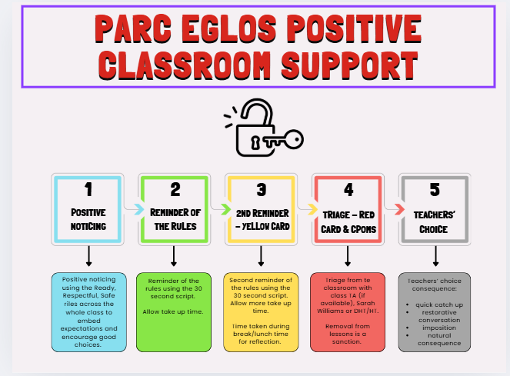

Students who commit a serious breach will be triaged immediately to the HT or DHT without support steps. This might include bullying (see separate whole school Anti-Bullying Policy),racist language, violence, homophobic behaviour.

Any student Triage will be recorded on CPOMs with the phase leader alerted to this entry. The class teacher leads the behaviour in the classroom using the Classroom Support Plan.

For the vast majority of pupils, a gentle reminder or nudge in the right direction is all that is needed. This may be a quiet word or a visual cue in order to correct the behaviour.

Although there are occasions when it is necessary, every minute a pupil is out of your lesson is one where they are not learning. Steps should always be taken with care and consideration, individual needs must be taken into account where necessary. Praise the behaviour you want to see and do not excessive attention to unwanted behaviour. All pupils must be given ‘take up time’ in between steps. It is not possible to leap or accelerate steps for repeated low-level disruption.
A reminder and warning of the expectations for pupils referring to the rules of ‘Ready, Respectful, Safe’ should be delivered privately to the pupil. The teacher makes them aware of their behaviour. The pupil has a choice to do the right thing. Pupils should be given time to respond to this request ‘take up time’.
A clear, verbal, final last chance warning should be delivered privately to the pupil making them aware of their behaviour and clearly outlining the consequences if they continue. Pupils will be reminded of their previous good conduct to prove that they can make good choices. It is important to give the pupil some time here to have the opportunity to reflect on what you have said and respond appropriately.
Scripted approaches at this stage are encouraged:
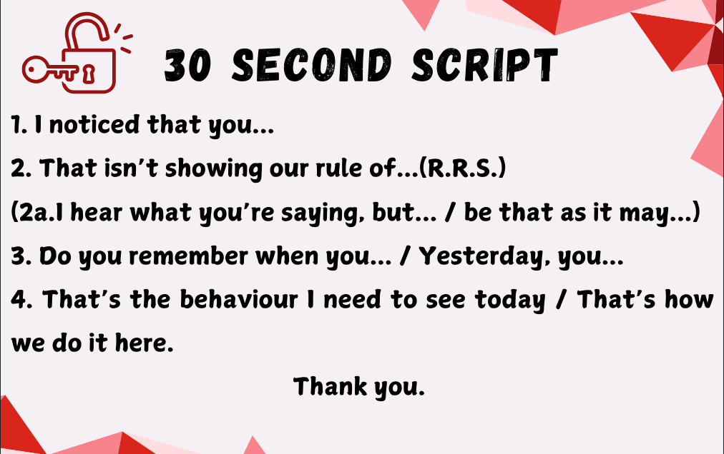
Walk away as soon as you have finished and praise pupils who are getting it right.
Following an incident where a pupil has been removed, it is important that the classroom teacher follows this up. ‘Picking up your own tab’ is a key principle here. The classroom teacher has the following options:
Catch up
Behaviour that results in a student being triaged may need no more consequences. However, it is very important, to catch up with the student before the next lesson, acknowledge that the previous lesson wasn’t good for anyone and that next lesson is a fresh slate. (This could take place with the pupil at the end of the day, in the playground, or phone call home.
Restorative Conversation
Walk and talk, stack books and talk, clean tables and talk. The Restorative Conversation is so much easier and more productive if it isn’t two people sat at a table making awkward eye contact. Much better to talk while doing something else.
The restorative 5:
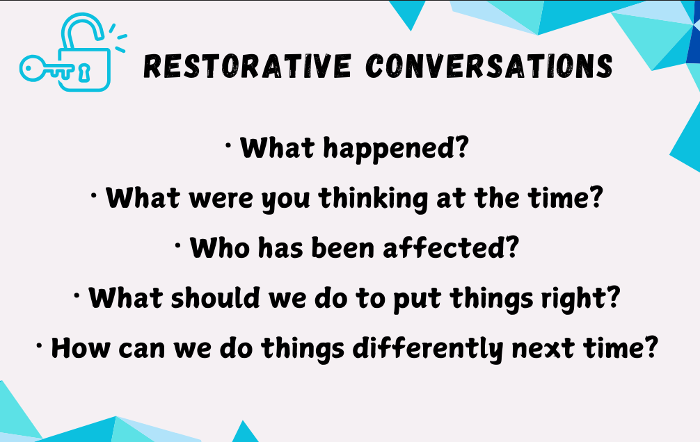These are questions for both the adult and the child. The purpose of the restorative
conversation is not to build to a climax of apology. Rather to get students to look in the
mirror and see their behaviour from a different perspective. It is a coaching conversation using a recent incident in sharp focus. There is real learning here, most of the time for the students, sometimes for everyone.

Imposition
Work that was not done in the lesson taken home, signed by a Parent/Guardian and returned before the start of the next lesson. Impositions are ideal for students who have not completed work due to their poor behaviour.

Natural consequence
Cleaning up the mess, repairing the display, reorganising the classroom, making up with peers are examples of natural consequences. If you can find a consequence that repairs the damage rather than just punishing the behaviour it all makes more sense.

What happens in Triage?
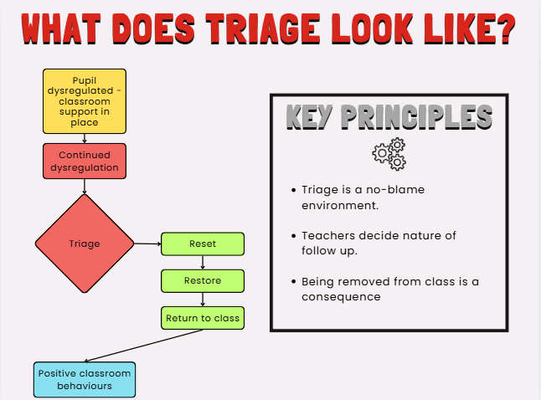

If a child needs to leave a space to aid self-regulation, a teaching assistant should, in the first instance, take this child to the nurture space or library. If a TA is not available, the DHT or HT will take this role.

1. Self regulating space
2. Opportunity to talk, access support and reset
3. Quiet place to study

Repair - Self regulating space
This is a quiet space using sensory aids/blackout tent/headphones/
happiness boxes (for regular attendees) until the student is ready to talk and access support to help regulate their emotions.

Restore - Space to talk, access support and reset
For most students the aim is for the repair/restore to take place straight away, if necessary, with the student staying in the nurture room for only one lesson and returning to their next lesson ready for learning. In some instances, there may be a need to unpick an underlying issue and this may take longer, to allow the student the time to regulate their emotions.

Return to learn - Quiet space to study
This would be the area where students would complete the work that they are missing due to being removed from class. There would always be an expectation that the work is completed. When ready and able, they will be returned to class. If notable amounts of work are missed, these should be sent home for completion, alongside a conversation with parents regarding why this work is being sent home, and the expectation and timescale for it to be returned to school.

Where patterns of behaviour are noted the following actions can be taken:
- Phase leaders to contact parents to discuss behaviour presentations.
- Internal exclusions can be used to support reflection
- Positive Transfer Inclusion – where a pupil attends an alternative CROFTY school for a short period of time 1-3 days to support reflection.
- Suspension
- Permanent exclusion.

Use of Suspension and Exclusion
The section of the Positive Relationship Policy which relates to exclusions is standard across all our schools – based on the principles within the DfE Guidance of 2017.
Key principles:
• The DFE statutory guidance 'Exclusion from maintained schools, academies and pupil referral units in England' 2017 will be followed.
• Only the headteacher can make the decision to exclude, this must be on disciplinary grounds.
• Due regard will be given to the Equalities Act and SEND code of practice.
• Informal exclusions (inc going home to ‘cool off’) will never be used and all exclusions will be recorded formally.
• ‘Transferred inclusion’ will be considered before the decision to exclude is made (see transferred inclusion guidance).
• Arrangements for parents to be notified immediately will be made by the headteacher. • The headteacher will contact the CEO on the same day to notify him of the decision made.
• A report of any suspension or permanent exclusion is made to the LGC through the termly HT report.
• The headteacher should ensure that any suspension is followed by a reintegration meeting which will include completion of a risk assessment with the parents (and child where appropriate) and future planning to reduce the risk of further exclusions.
• Where exclusions exceed 5 consecutive days alternative arrangements will be put in place to provide education.

Transferred Inclusion
• All the schools within Crofty Trust are committed to reducing exclusions from school where ever possible. In order to facilitate this the schools work together to facilitate transferred inclusions between the schools. This means that a child may attend a different school for a period of a few days, with the agreement of their parents.
• Where a pupil’s behaviour and conduct has been such that a suspension is considered by the headteacher, the alternative of a transferred inclusion will always be considered in the first instance.
• When a school is considering use of a transferred inclusion a risk assessment (along with other paperwork) will be completed in advance and shared with the receiving school to ensure that this is the most appropriate action and that appropriate care can be offered by the receiving school.

Exclusion:
In extreme cases Parc Eglos School may use temporary or permanent exclusion.
Permanent exclusion will only be used as a last resort, in response to a serious breach or persistent breach of the schools behaviour policy; and where allowing the pupil to remain in school would seriously harm the education or welfare of the pupil or others in the school. The DFE statutory guidance 'Exclusion from maintained schools, academies and pupil referral units in England' will be followed to ensure that all decisions taken remain lawful and that those people who need to be informed have the appropriate information shared with them.

OFF Rolling
Ofsted’s definition of ‘off-rolling’ “The practice of removing a pupil from the school roll without a formal, permanent exclusion or by encouraging a parent to remove their child from the school roll, when the removal is primarily in the interests of the school rather than in the best interests of the pupil. Off-rolling in these circumstances is a form of ‘gaming’. There are many reasons why a school might remove a pupil from the school roll, such as when a pupil moves house or a parent decides (without coercion from the school) to home educate their child. This is not off-rolling. If a school removes a pupil from the roll due to a formal permanent exclusion and follows the proper processes, this is not off-rolling.” The school’s within Crofty Multi Academy Trust follow all correct procedures in line with the spirit of the law, making decisions which are motivated by the best interests of the pupils concerned.

Positive Handling
Crofty Schools have an agreed Safe Touch Policy which is standardised across all schools. The key principles of this are that:
• Research shows clearly that healthy pro-social brain development requires access to safe touch as one of the means of calming, soothing and containing distress for a frightened, sad or angry child.
• It is essential for all children to learn the difference between safe and unsafe touch and to experience having their strongest emotions contained, validated, accepted and soothed by a significant adult.
• If children are behaving in unacceptable, threatening, dangerous, aggressive or out of control ways, they have not yet learned how their strongest emotional reactions can be contained, channeled and communicated safely. In recognition of this, under agreed and supervised conditions, specially trained staff will consider using safe touch as one of the means available to them for:
● Calming a distressed child.
● Contain an angry child.
● Affirm or encourage an anxious child or a child with low self-esteem.

This common approach is reflected in the standard statement below which is included in the Behaviour policy of all Crofty Schools.

Safeguarding,
Sexual violence Child on Child Abuse – including Sexual Violence, Online Sexual Abuse, Sexual Harassment and Harmful Sexual Behaviour is addressed within Crofty’s Child on Child Abuse Policy. All schools follow this policy and will have the statement below within their school behaviour policies. Each school will also create their own Anti-Bullying Policy in consultation with the school community. At Parc Eglos School there is a zero-tolerance approach to sexual violence and sexual harassment - it is deemed never acceptable. It will not be tolerated and should never be passed off as “banter”, “just having a laugh” or “part of growing up”. Challenging physical behaviour (potentially criminal in nature), such as grabbing bottoms, breasts and genitalia, pulling down trousers, flicking bras and lifting up skirts is regarded as sexual harassment.
The school recognises that dismissing or tolerating such behaviours risks normalising them; and in not recognising, acknowledging or understanding the scale of harassment and abuse and/or downplaying some behaviours related to abuse it can lead to a culture of unacceptable behaviour and pupils feeling unsafe. We recognise that addressing inappropriate behaviour (even if it appears to be relatively innocuous) can be an important intervention that helps prevent problematic, abusive and/or violent behaviour in the future. As such, any such behaviour will be sanctioned in line with this policy and under guidance from https://www.gov.uk/government/publications/sexual-violence-and-sexual-harassment-between-children-inschools-and-colleges and the school Safeguarding policy.

Use of reasonable force.
Members of staff may need to use reasonable force to prevent pupils committing an offence, injuring themselves or others, or damaging property, and to maintain good order and discipline in the classroom. Reasonable force will only be used as a last resort when all other strategies have been ineffective. Team Teach techniques seek to avoid injury to a pupil, but it is possible that bruising or scratching may occur accidentally, and these are not to be seen necessarily as a failure of professional technique, but a regrettable and infrequent “side-effect” of ensuring that pupils remain safe. Use of separate spaces In this school we may require a dysregulated pupil to be placed in an area away from other pupils for a limited period of time. In this situation children will always be under the direct supervision of an adult. In addition to this, we may request dysregulated pupils to attend a school in the MAT for 1-2 days for a transferred inclusion, they will be supported by a member of staff from XX School. Any situation that prevents a child from leaving a room of their own free will only be considered in the short term and very exceptional circumstances; for example, where a child's behaviour presents significant risk of harm to themselves or others. The school will follow the DfE guidance ‘Behaviour and discipline in schools’ at all times.

E Safety, online abuse and Harassment (See Online Safety Policy)

SEND
School behaviour policies recognise that some pupils will need a different approach and schools will make provision for this including behaviour support plans and risk assessments. Where appropriate these provision for these pupils will be planned as part of the SEND provision, including referrals to outside agencies where appropriate.

Communication and Role of Parents
The Behaviour Policy for each school will be available to parents on the school website and will be discussed as part of the child’s induction to the school. In addition parents will receive reminders throughout the year of the school expectations, including how parents can support their child to succeed. Schools recognise the vital role that parents play in the education of their child and will work positively with them to secure the best outcomes. Training All staff and volunteers are provided with training as part of their induction to the school and organisation, this includes the school Behaviour Policy and associated policies alongside the staff code of conduct and safeguarding training. At the start of each year, and whenever the policy is reviewed staff receive an update of agreed approaches.

Monitoring/ Data Collection
All Crofty have well established systems in place for recording behaviour incidents. Schools analyse these to identify trends and reflect on the effectiveness of the policy. Analysis also identifies individuals where early intervention is required. Schools report on the effectiveness of their Behaviour Policies to LGC’s. Behaviour, suspension, transferred inclusion, use of alternative provision and attendance are reviewed termly as part of the school improvement cycle with a summary of significant issues reported to the School Improvement committee of Trustees.

